REVISI CHAPTER 1
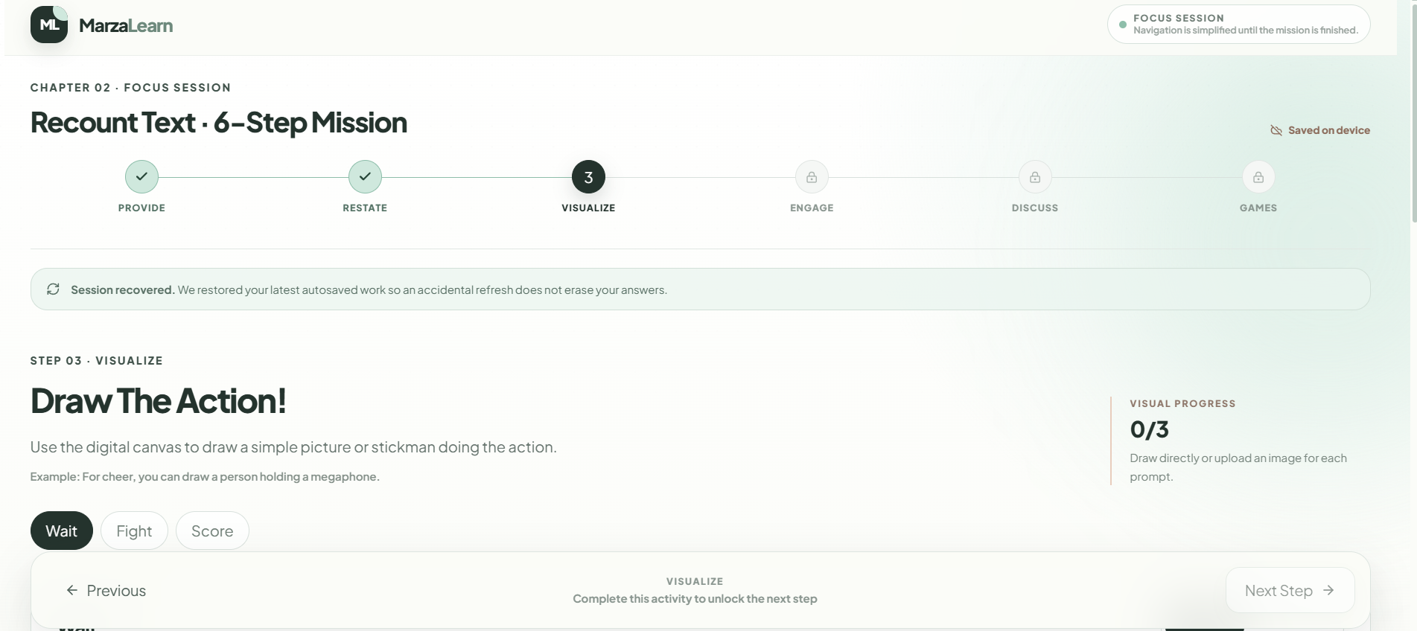
Diganti jadi Or include a photo that you think can describe the word

TAMBAHAN CHAPTER 1 (DIBAGIAN 10.ULTIMATE PJBL)
🎯 YOUR MISSION
Create a 1-minute descriptive video about an Indonesian athlete.
Your project combines writing, speaking, and digital creativity.
✍️ STEP 1 — WRITE YOUR SCRIPT
Choose one Indonesian athlete and write a short descriptive script.
Your script should include:
1. Identification
Who is the athlete? What sport do they play?
2. Description
Describe their physical appearance and personality.
3. Language Use
- At least 3 adjectives
- At least 1 adverb
- Simple Present Tense
🎥 STEP 2 — CREATE YOUR VIDEO
Turn your script into a 1-minute descriptive video.
You may use Canva, CapCut, or another video-editing tool.
Your video should include:
- your introduction;
- the athlete's identification;
- physical description;
- personality description;
- clear pronunciation;
- confident delivery.
📤 STEP 3 — SUBMIT YOUR PROJECT
Upload your video and submit the project link to your teacher.
✅ PROJECT CHECKLIST
Before submitting, make sure your video has:
☐ Identification
☐ Physical appearance
☐ Personality
☐ At least 3 adjectives
☐ At least 1 adverb
☐ Simple Present Tense
☐ Clear pronunciation
☐ Approximately 1 minute
☐ Digital presentation

👀 TASK MODELING
Before creating your project, watch the example video below.
Pay attention to how the speaker:
- introduces the athlete;
- describes physical appearance;
- describes personality;
- uses adjectives and adverbs;
- uses the Simple Present Tense;
- organizes the information into a short description;
- delivers the description clearly and confidently.
🎬 Example Video: https://youtu.be/Pk5xGP5pn4Q?si=YY5uqW7TOvmeP04T
💡 NOTICE!
After watching the example, ask yourself:
How does the speaker start the description?
What information does the speaker include?
Which adjectives are used?
How does the speaker describe the athlete's personality?
How does the speaker end the description?
🚀 NOW IT'S YOUR TURN!
Use the example as a model, but create your own original description and video.

